**Evidencia de precios**

Cliente reactivado – Foco Banrural – No consolida Banrural – VeryLow - SF

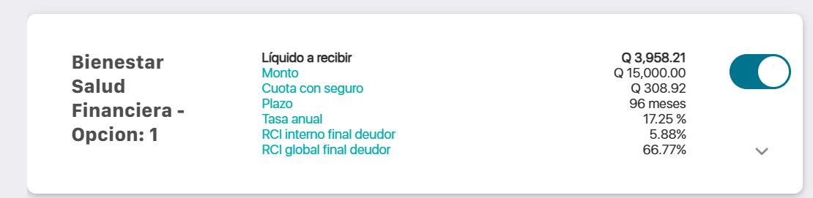

Cliente reactivado – Foco Banrural – Sí consolida Banrural – VeryLow - SF

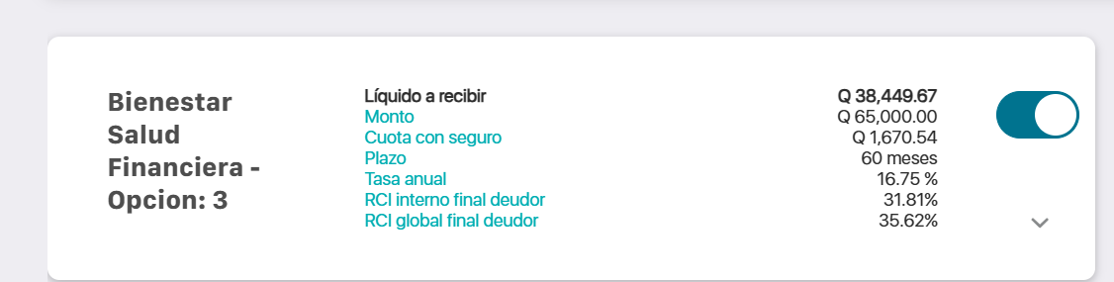

Cliente reactivado – Foco Banrural – Sí consolida Banrural – SF - VeryLow

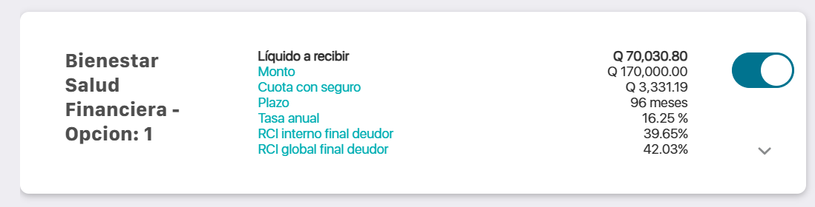

Cliente reactivado – Foco Banrural – Sí consolida Banrural – SF - Medium

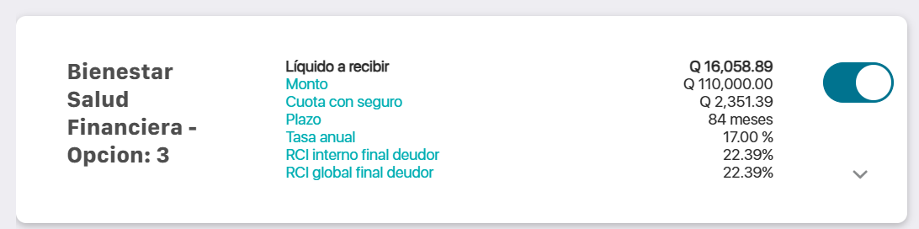

Cliente reactivado – Foco Banrural – No consolida Banrural – Liquidez - Medium

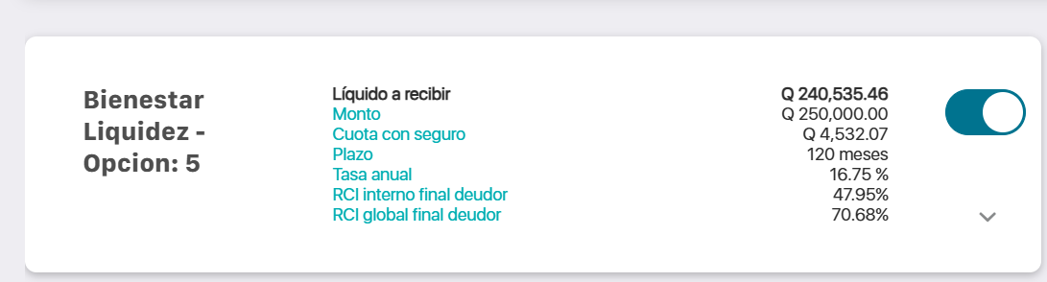

Cliente reactivado – Foco Banrural – Consolida Banrural – SF - VeryLow

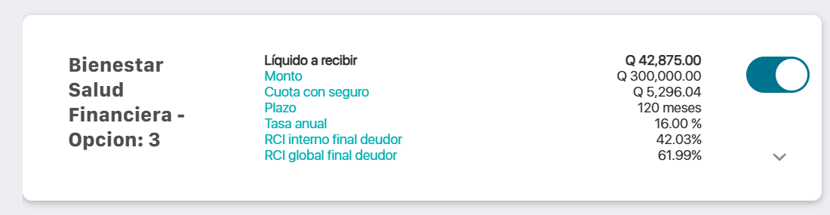

Cliente reactivado – Foco Banrural – No consolida Banrural – Liquidez - VeryLow

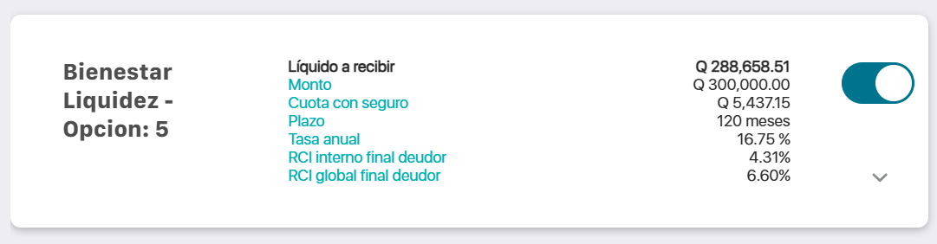

Cliente reactivado – Foco Banrural – Sí consolida – Liquidez - VeryLow

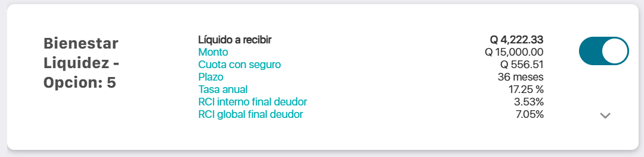

Cliente reactivado – Foco Banrural – No consolida Banrural – Liquidez - Low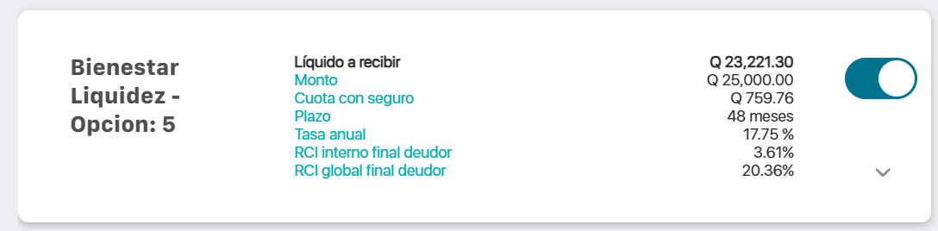

Cliente reactivado – Foco Banrural – No consolida Banrural – Liquidez – Low

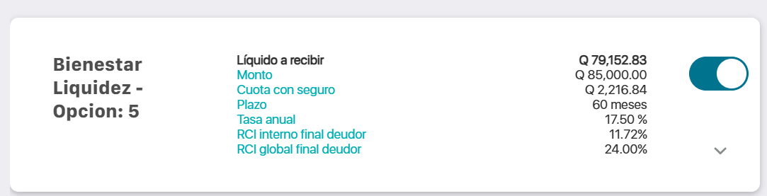

Cliente reactivado – Foco Banrural – No consolida Banrural – Liquidez – Low

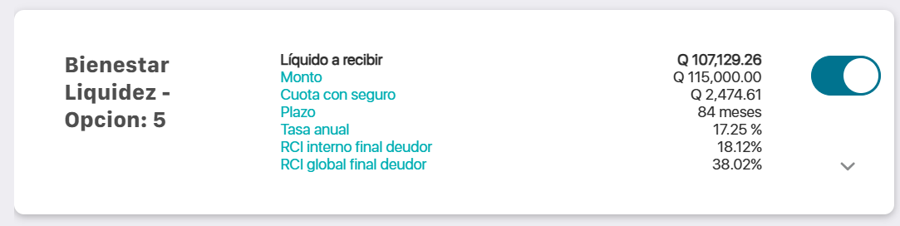

Cliente reactivado – Foco Banrural – No consolida Banrural – Salud Financiera – VeryLow

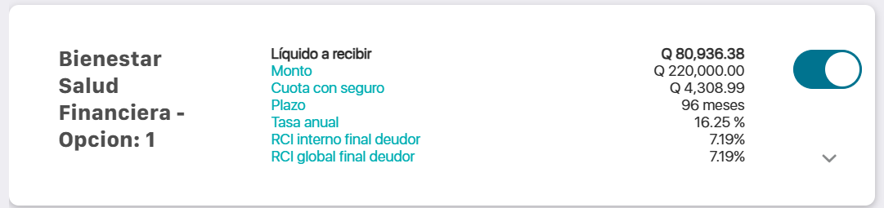

Cliente reactivado – Foco Banrural – No consolida Banrural – Liquidez – VeryLow

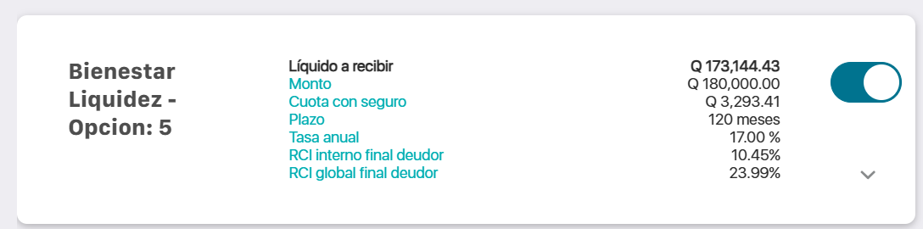

Cliente Reactivado – Foco Banrural – Sí consolida Banrural – VeryLow

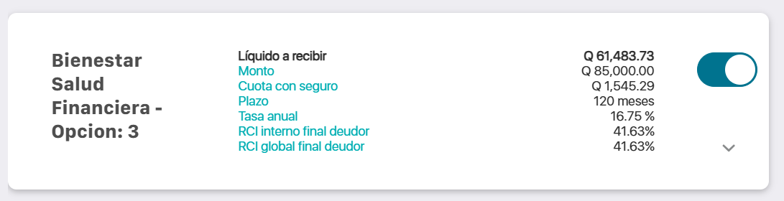

Cliente reactivado – Foco Banrural – No consolida - Liquidez - Low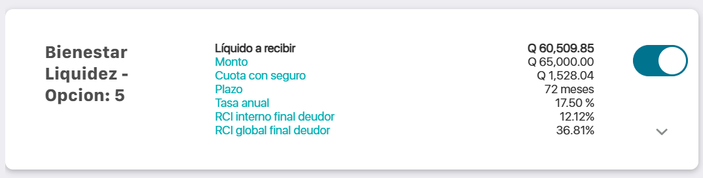

Cliente reactivado – Foco Banrural – Consolida – Salud Financiera – Low

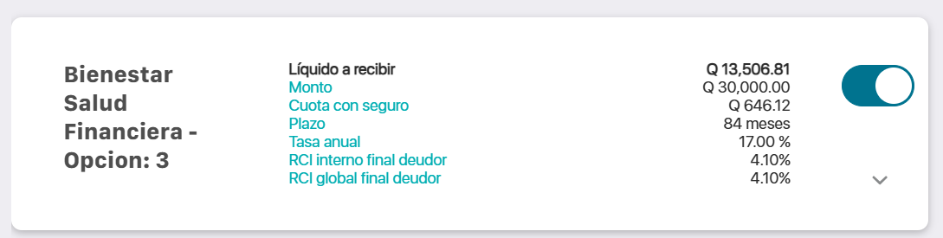

Cliente reactivado – Foco Banrural – Consolida – Salud Financiera – Medium

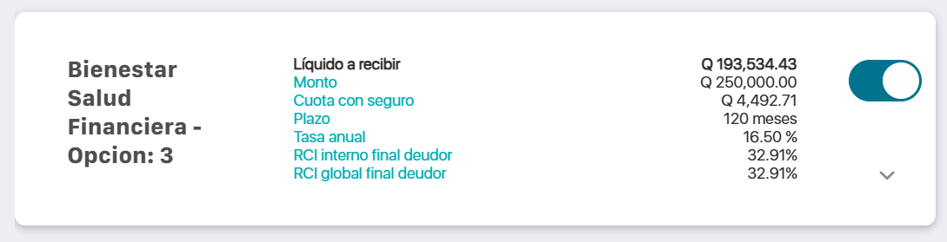

Cliente existente – Foco Banrural - Consolida – Salud Financiera – Medium

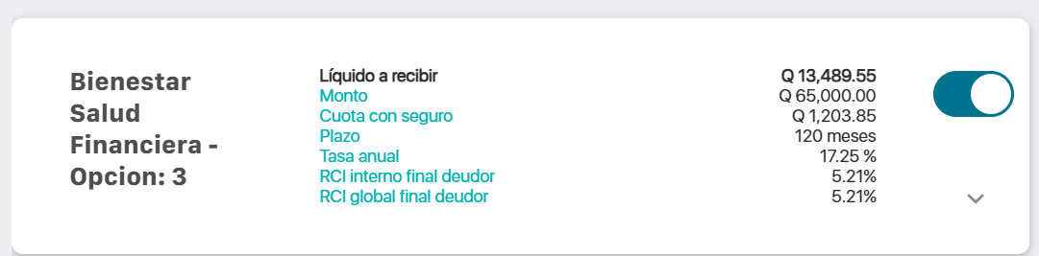

Cliente reactivado – Foco Banrural – Liquidez – Medium – No consolida

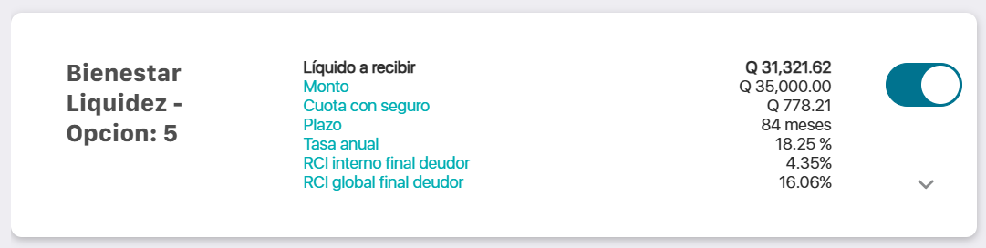

Cliente reactivado – Foco Banrural – No consolida – Liquidez - Low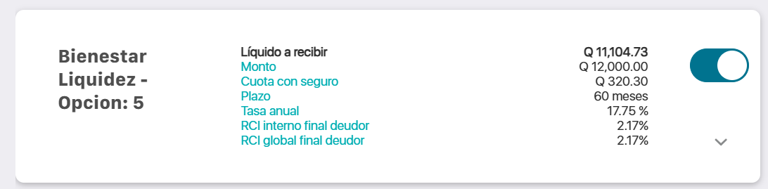

Cliente reactivado – Foco Banrural – Consolida – Salud Financiera – VeryLow

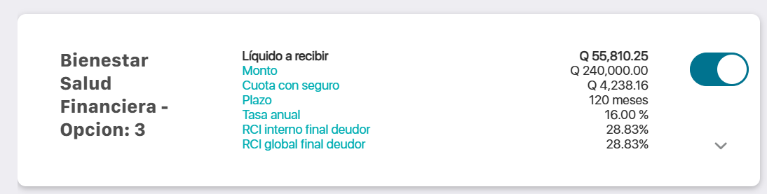

Cliente existente – Foco Banrural – Sí consolida Banrural – VeryLow – Salud Financiera

